**Prediction in orange**

**Aim**: To predict whether the given dataset is of fruit or vegetable.

**Description**:

This dataset contain numerous feature which diffrenciate whether the given dataset is of vegetable or fruit. The target variable is classification i.e Is it fruit or vegetable.

**Data selection:**

We have given the url of the dataset which contain 35 instances and 9 features of fruit and vegetables.

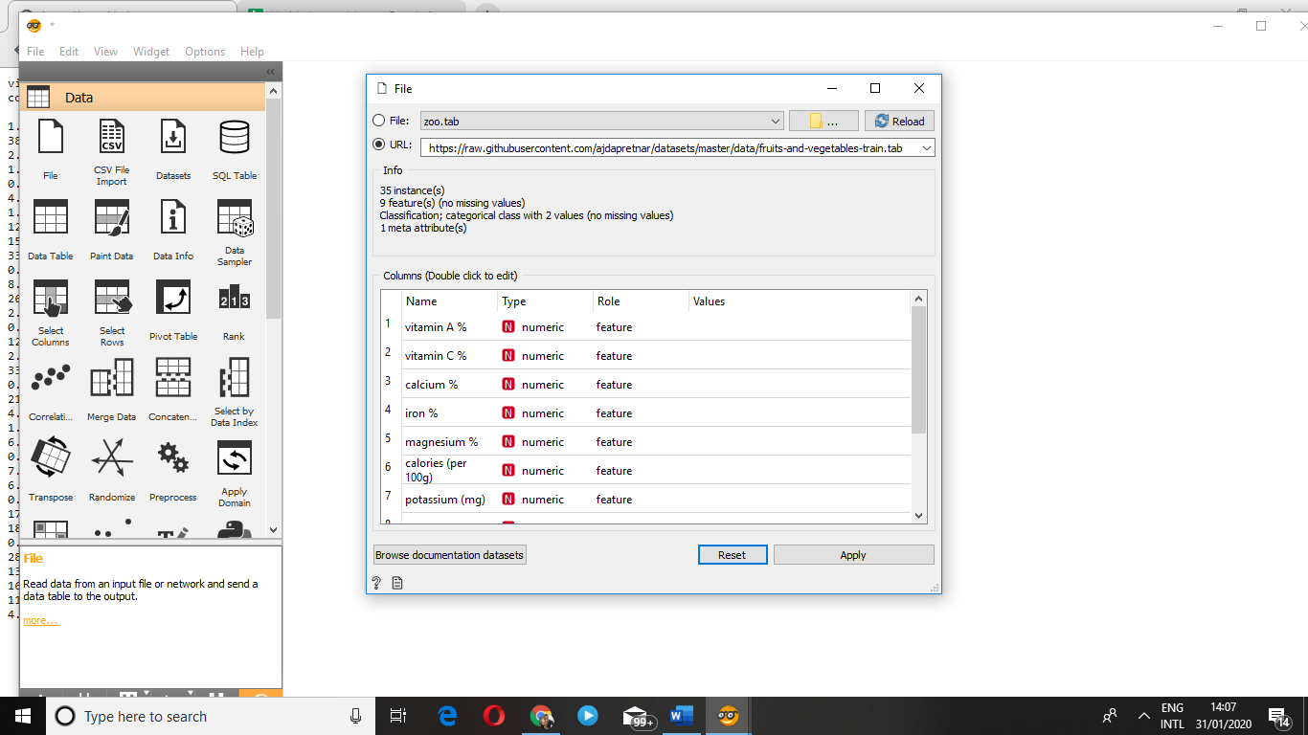

Data visualization:

We visualize the data by using data table and classification tree.

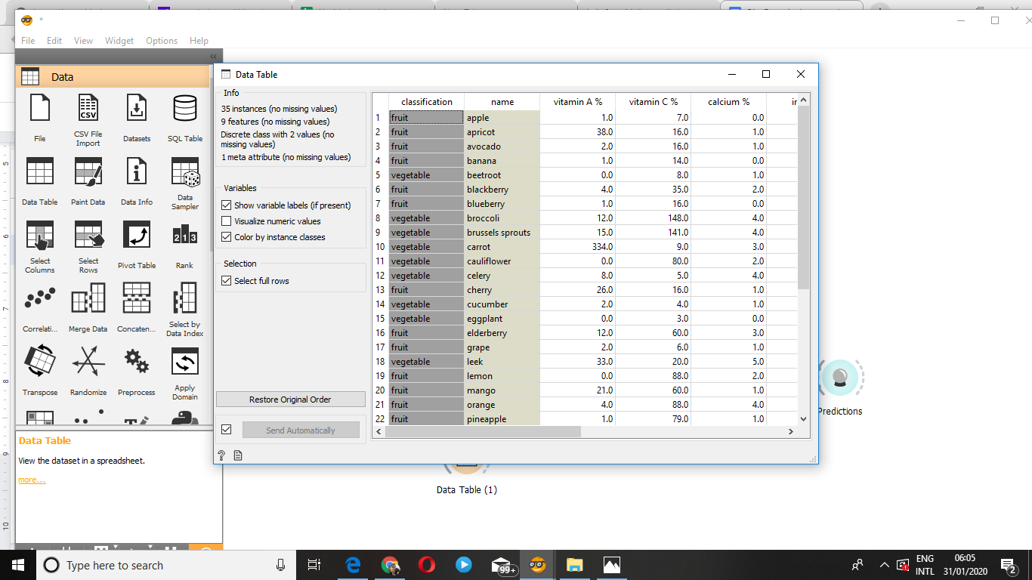

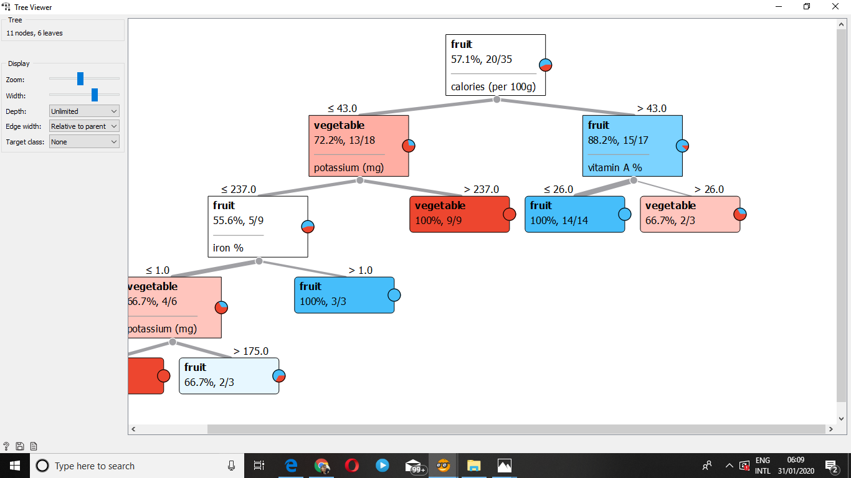

Again ,You have to create the the dataset of plants which you need to predict and visualize it in data table. 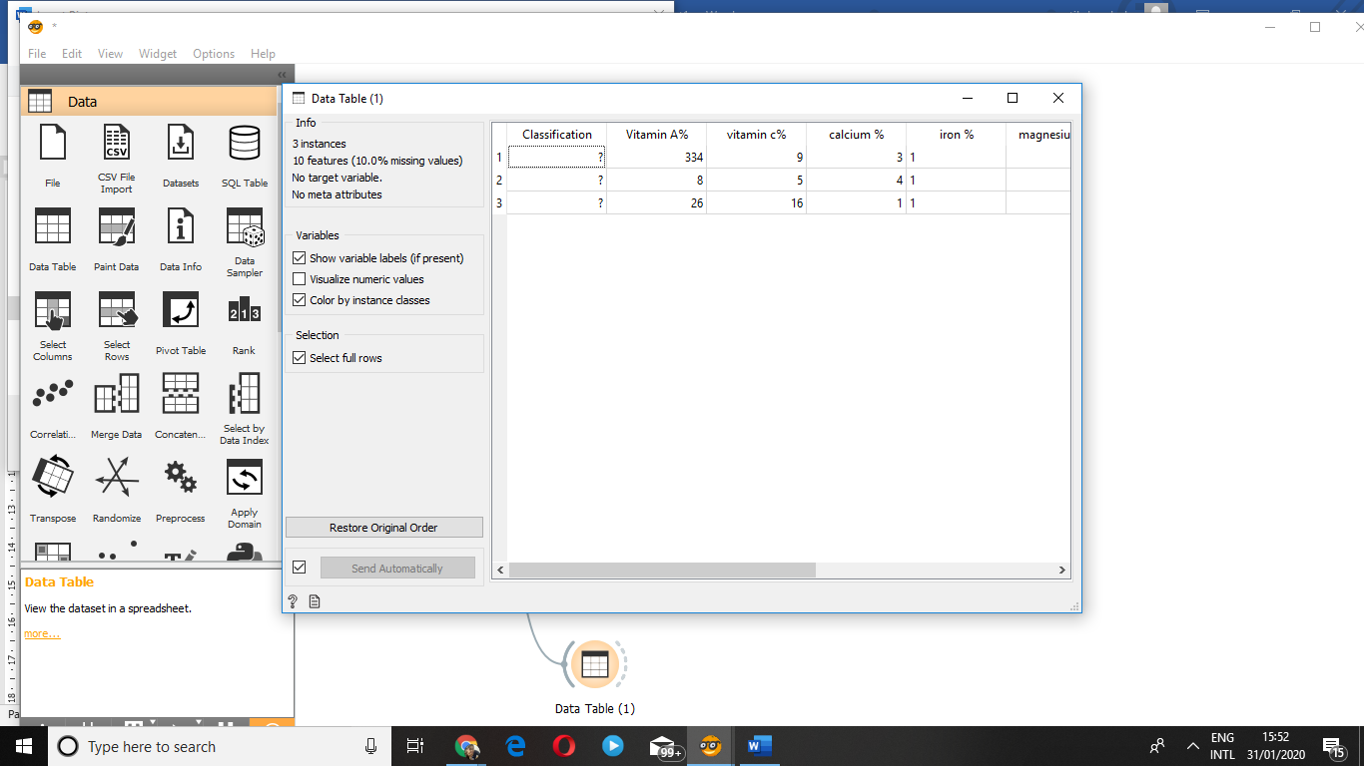

By using prediction widget you need to predict whether the plant is vegetable or fruit .

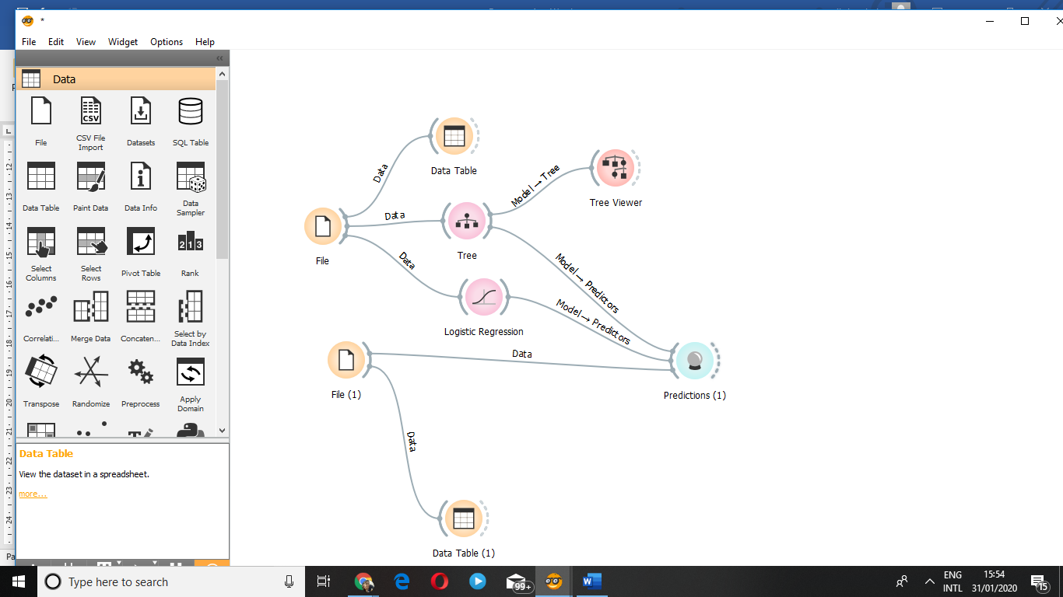

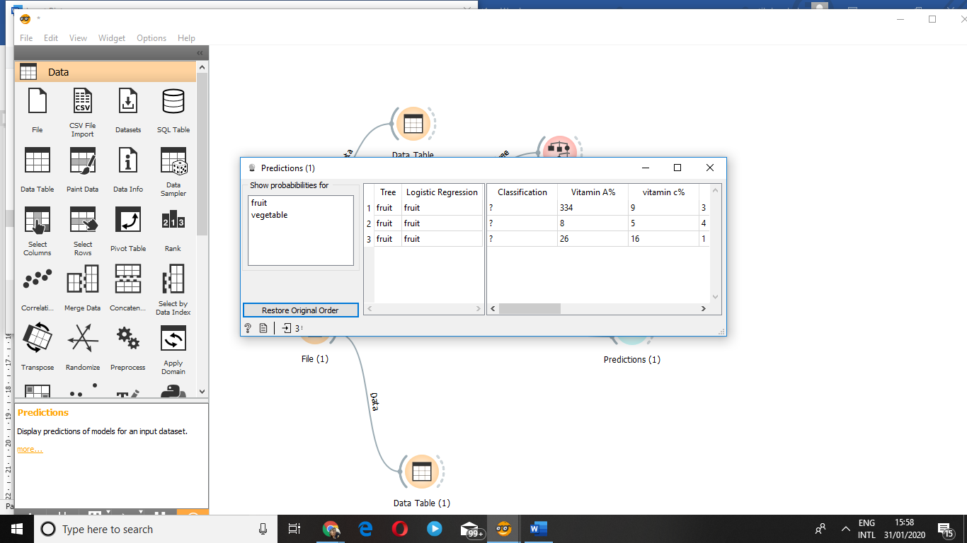

The given prediction is again checked by logistic regression.